Manoj Vasa

11/18/2016

Intro to Technical Communication

How to Make Waffle Fries

**Introduction**

These instructions will help you in making waffle fries. Waffle fries are waffle shaped French fries that have a checkered pattern. Their shape and form gives them a nice texture and taste that makes them an interesting party or casual treat. You don’t need to have any cooking experience to be able to make them. These fries are a nice snack for the guests and don’t require more than thirty minutes to prepare. This quick snack is both delicious and unique for any event.

**Materials**

1. Waffle fry cutter

Russet Potatoes

1. Frying pan
2. Skimmer
3. Large Bowl
4. Paper towels

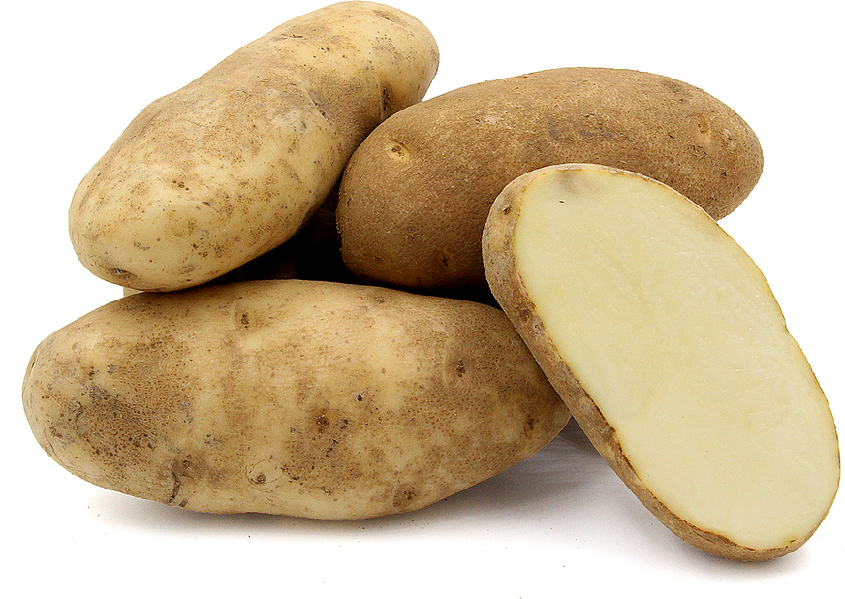**Ingredients**

1. 4 Russet potatoes
2. 1-quart peanut oil
3. Salt
4. Cajun seasoning

Fig. 1

You can use russet potatoes. Other potatoes are alright too.

Source: vhttp://www.specialtyproduce.com/produce/Russet_Potatoes_7843.php

**Suggestions:**

**Peanut Oil**

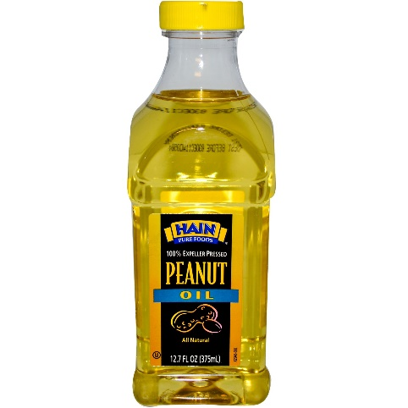

Fig. 2

Peanut oil is highly recommended as it has a higher

cooking temperature among other oils.

Source: <http://www.iherb.com/hain-pure-foods-peanut-oil-12-7-oz-375-ml/33271>

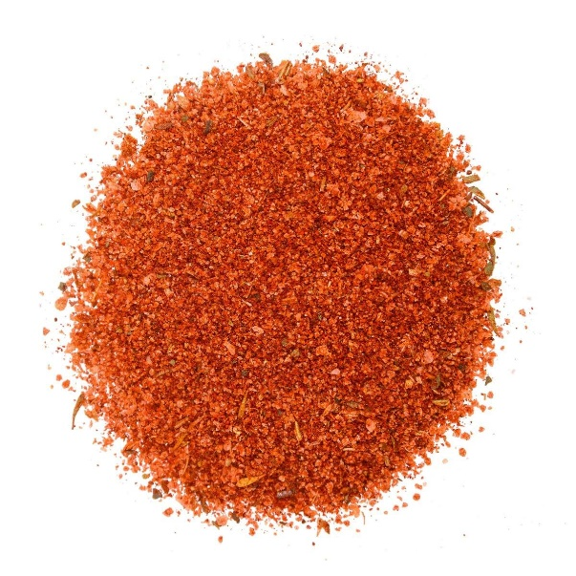**Cajun Seasoning**

Fig. 3

This is a personal preference. Cajun seasoning gives the fries

a savory rich taste. Other seasonings can be used

Source: <https://www.thespicehouse.com/cajun-seasoning-regular>

**Instructions**

1. Wash the potatoes.

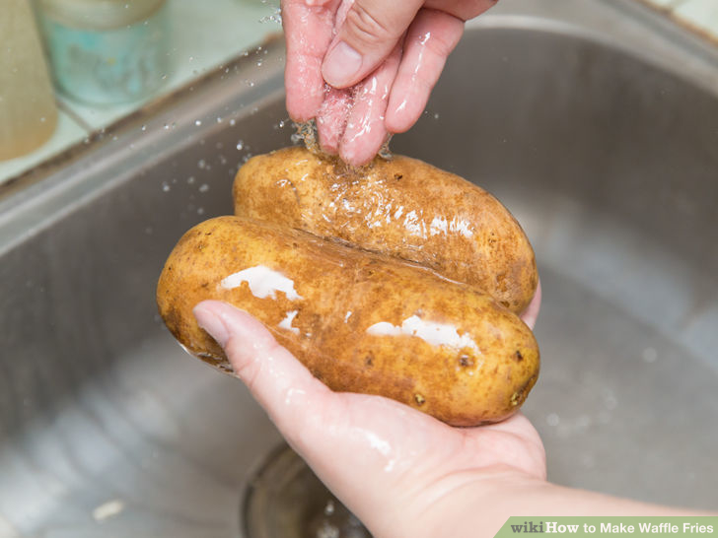Cleaning Potatoes

Fig. 4

Wash the potatoes first so they’ll be clean.

Source: http://www.wikihow.com/Make-Waffle-Fries

1. Let the potatoes dry after washing and wipe with paper towels.
2. Place potatoes next to waffle fry cutter.
3. Take a potato and slide it down on the waffle fry cutter. This process is shown in figures 5 and 6.

Caution: Waffle fry cutter blades will be very sharp. Be careful of the blades.

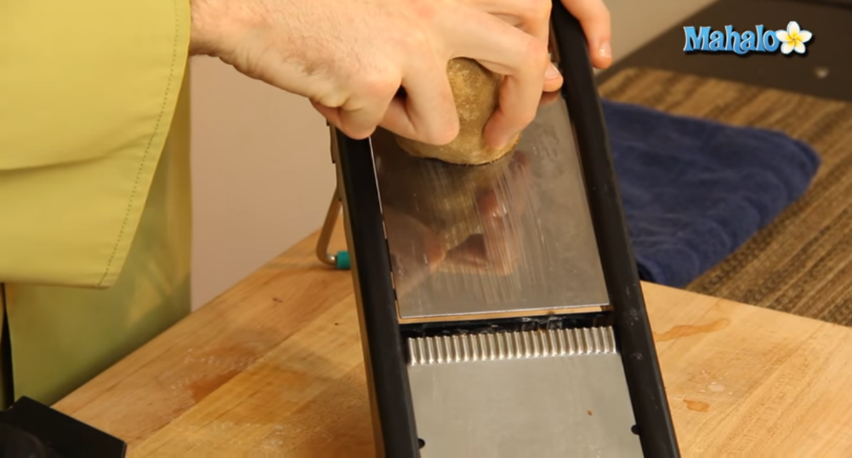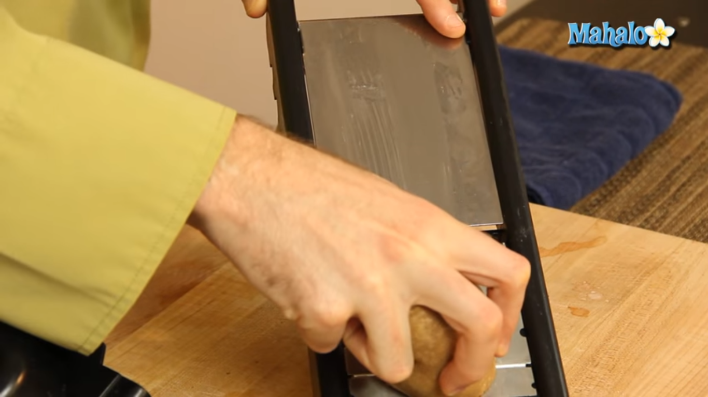How to Cut the Waffle Fries

Fig. 6

Quickly slide the potato down the cutter. Beware of the sharp blades of the cutter.

Source: How to Waffle Cut a Potato Using a Mandoline: https://www.youtube.com/watch?v=8ZtltCnCtkw

Fig. 5

Start with the potato at the top of the cutter.

Source: How to Waffle Cut a Potato Using a Mandoline: https://www.youtube.com/watch?v=8ZtltCnCtkw

1. Place the potato back at the top of the waffle fry cutter and rotate the potato by 90 degrees. This process is visualized in figure 7.

Potato Surface After First Cut

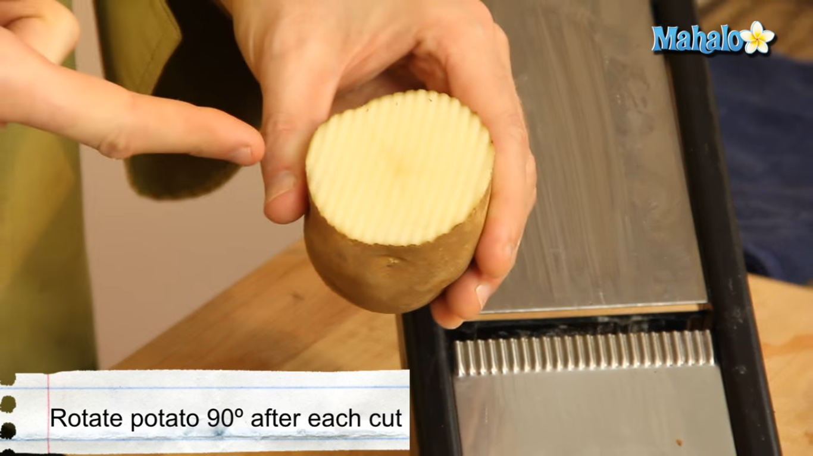

Fig. 7

After the first cut the potato has the pattern of lines going up and down. The next cut has to be perpendicular to these line as indicated by the black arrows.

Source: How to Waffle Cut a Potato Using a Mandoline: https://www.youtube.com/watch?v=8ZtltCnCtkw

1. Slide it down on the waffle fry cutter.
2. Repeat steps 3 and 4.
3. Pour peanut oil into frying pot and heat up to 375o F.

Caution:Oil will be at very high temperatures through the process. Be sure to not let the oil splash too much.

1. Place two paper towels in large bowl and set aside.
2. Carefully drop the waffle cut potatoes into the frying pan.

Caution: Don’t let oil splash over the pot. This could start a fire.

1. Flip the potatoes and let fry for 3-4 minutes with a skimmer as shown in figure 8.

Flipping Fries While Frying Them

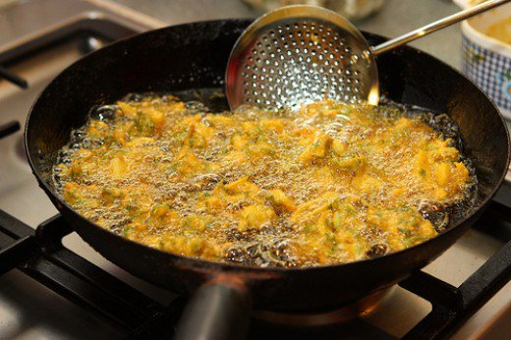

Fig. 8

Flipping the fries from time to time will fry them properly.

Source: 3 Ways to Check Deep Fry Oil Temp Without a Thermometer

https://delishably.com/food-industry/Deep-Frying-3-Ways-to-Check-the-Oil-Temperature-Without-a-Thermometer

1. After the fries reach a golden crisp texture, place them in bowl.
2. Pat down the fries with paper towels to soak up some of the oil.
3. Sprinkle a pinch of salt and drizzle some Cajun seasoning over the waffle fries for extra taste.
4. Let the fries cool for 20 seconds.
5. Enjoy the waffle fries with your choice of sauce.

**Conclusion**

Enjoy the fries. They go well with a large assortment of sauces. Feel free to experiment with different combinations to get your favorite side for these fries. Their waffle texture makes them easier to use when dipping in sauces. The fun snack is a quick and enjoyable treat that can be made by anyone.

Finished Fries

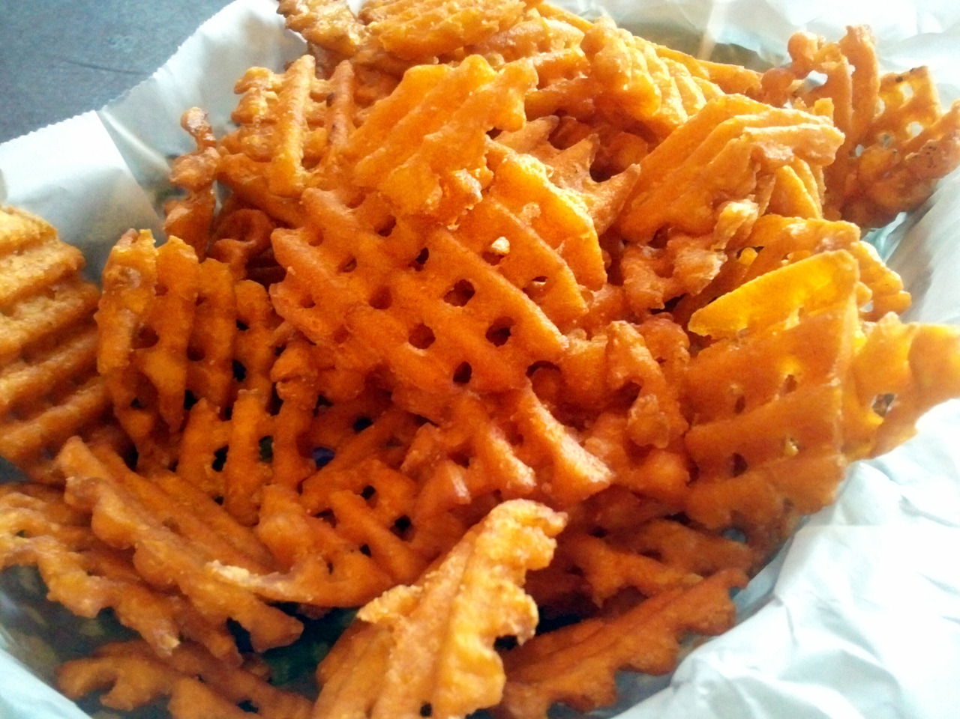

Fig. 9

Here’s what the final product will look like.

Source: Buena Vista Supper Club

http://bvsc.tumblr.com/post/25811570112/sweet-potato-waffle-fries-from-the-filling

Enjoy the fries!